**Step 1:** Register an account Rezer (<https://pay.rezer.app/login>)

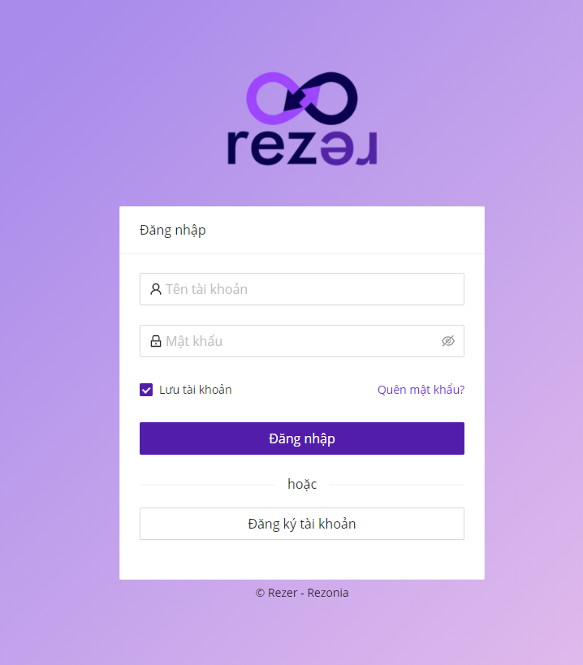

Choose “Đăng ký tài khoản”

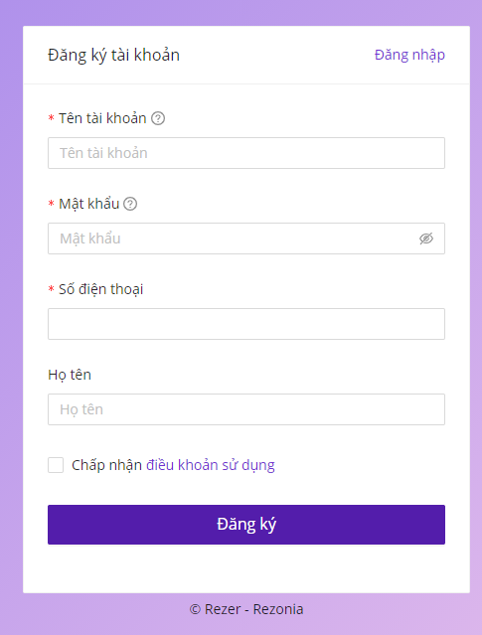

*Notice : Only one phone number for one register

**Step 2:** Login and input OTP

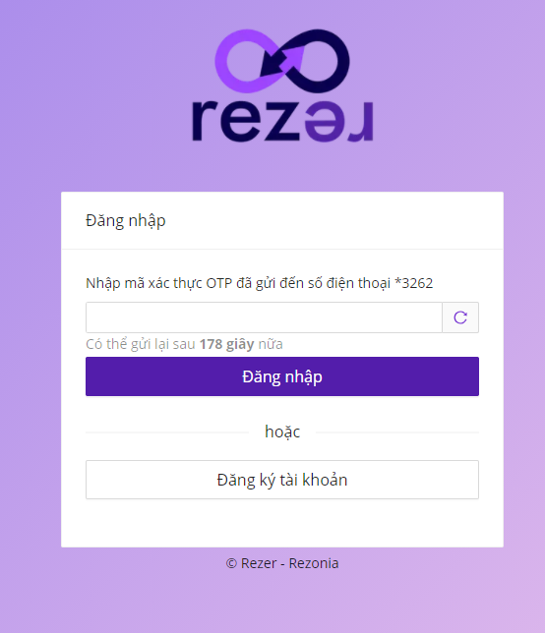

**Step 3:** Create API in “Tích hợp API” -> “Quản lý API” -> + “Thêm API”

(When we have transactions (Banking,MOMO…), Rezer will call Callback URL and push these transaction data)

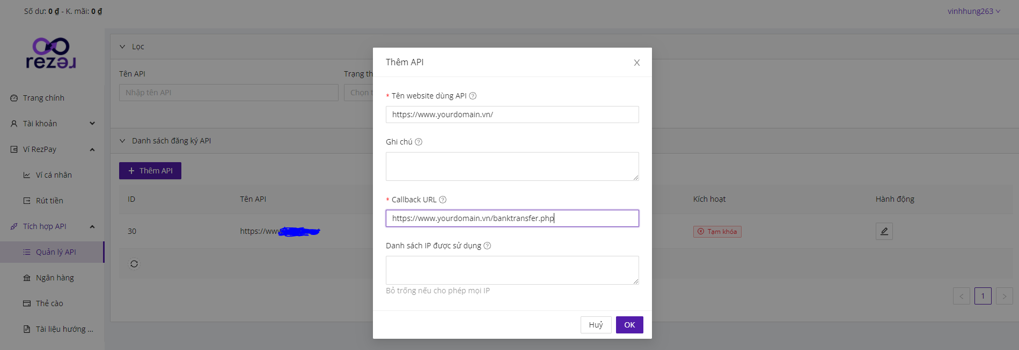

Tên website dùng API: [**https://www.yourdomain.vn/**](https://www.yourdomain.vn/)

Callback URL: **http://** **www.yourdomain.vn/banktransfer.php**

Example Data:

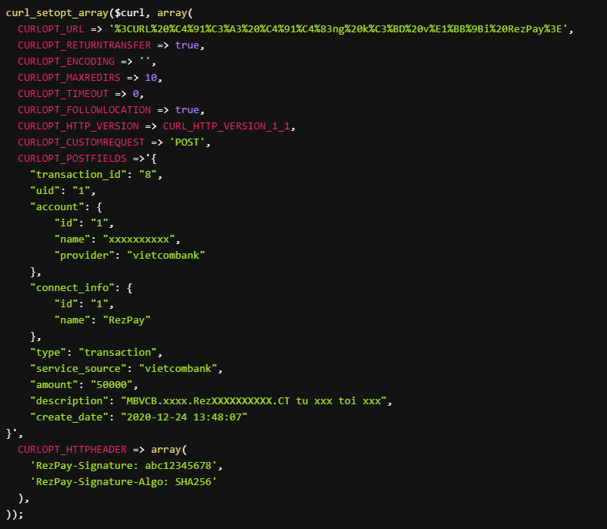

**Step 4:** Register bank account (which account received from your customers)

“Tích hợp API” -> “Ngân hàng” -> “+ Thêm tài khoản”

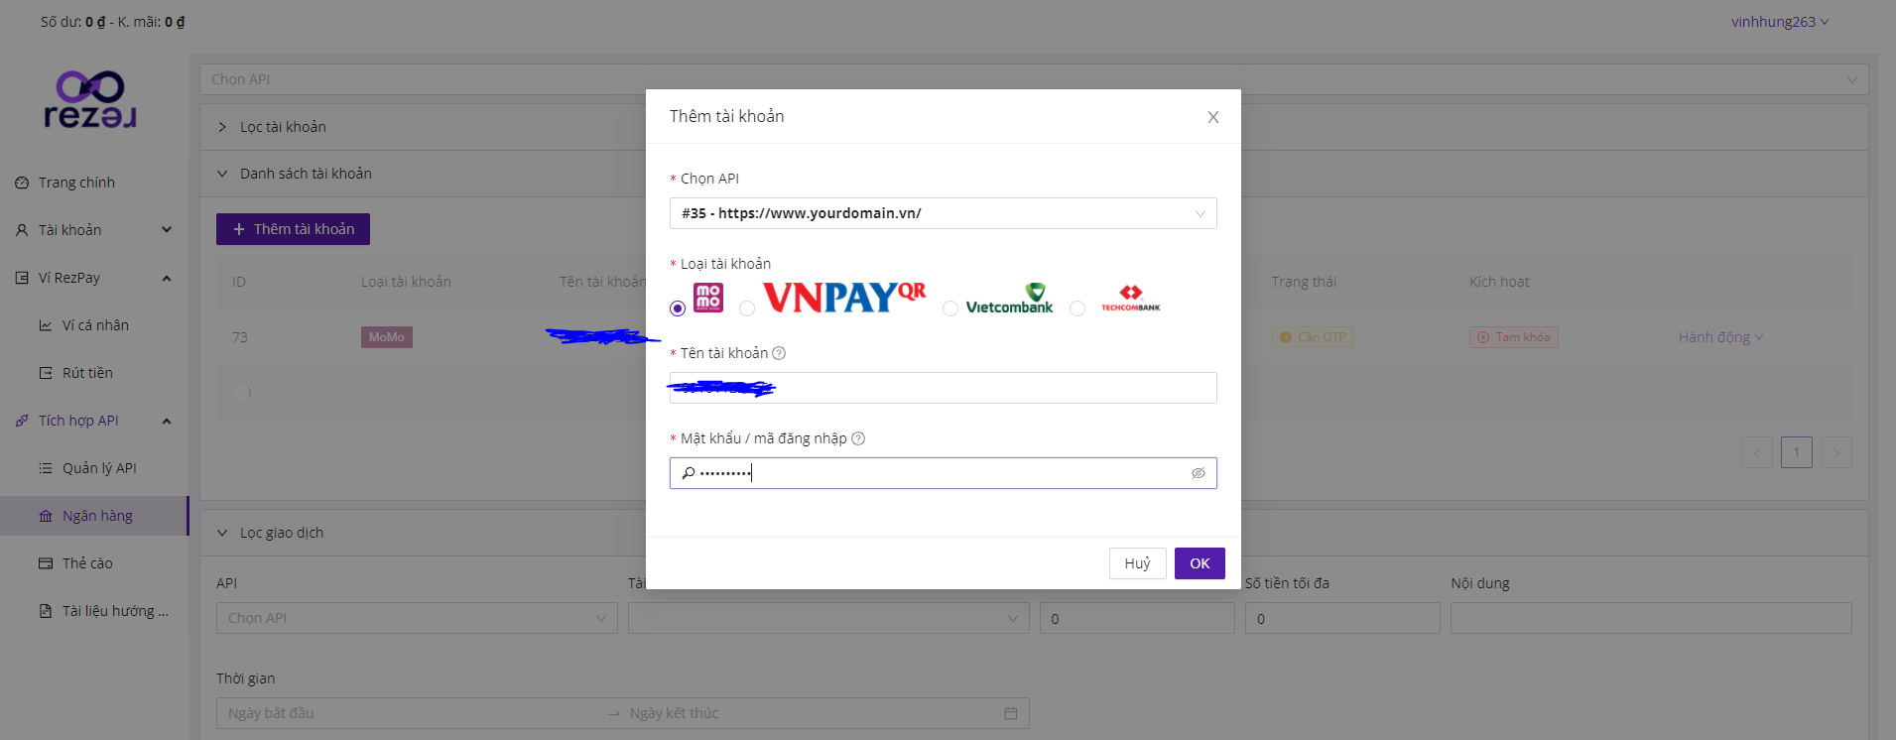

Choose API and fill in inputs

***Notice****:* When using API for MOMO, you should log out this account (MOMO) from all devices (Because Rezer supports MOMO to listen/receive transaction at a time. So that, if you need to use MOMO on mobile, you must disable (inactive/block) on this MOMO account on Rezer temporarily.

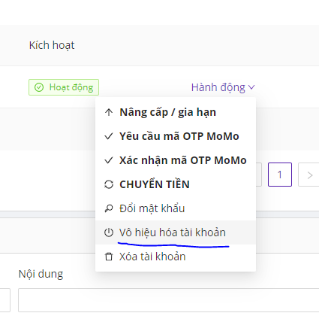

**Step 5:** After registering API and Banking Account, you **copy Secret key** **of** **API** and use in file banktransfer.php

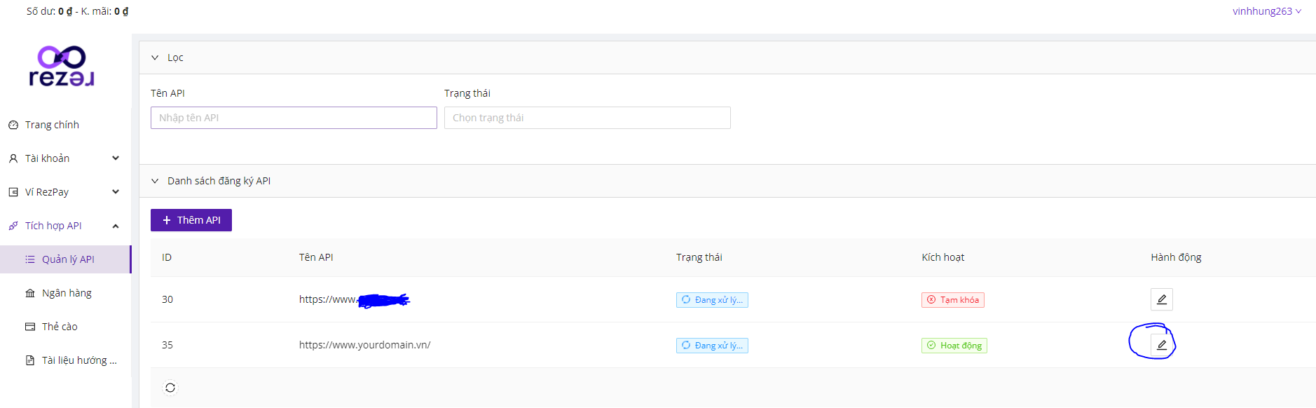

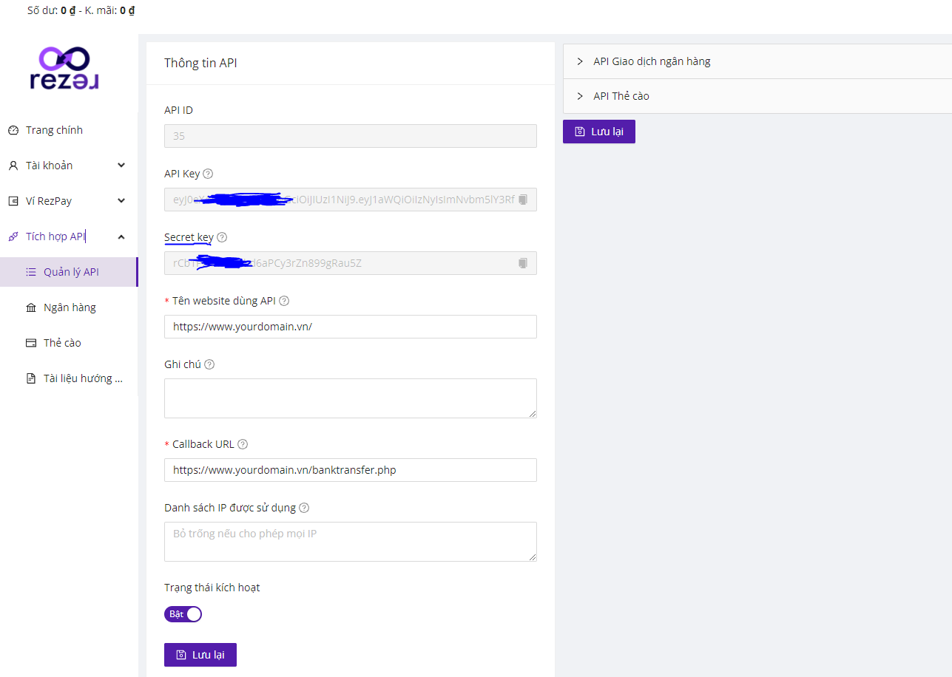

When registered banking accounts have transactions, Rezer shows history of transaction(logs and action) for user to follow). You also can resend callback api to check your API (Click “Hành động). 